FACT TOGETHER 2021

ARTIST COMMISSION

Fund to support artists make work online

We will give a grant to help 4 individuals in the North of England to create work online, and on FACT’s LED window.

This guide can help you think about your project and how to apply.

Guidance for applicants - Easy read version

July 2021
FACT is the name of our art organisation. We present films, art and creatives technologies.
Our gallery is in Liverpool, in the north of England.

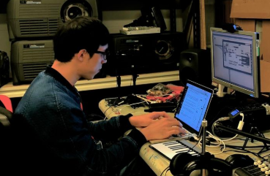
FACT TOGETHER will support artists to make new work to share online as part of a digital residency.

FACT TOGETHER commissions artists at an early stage in their career to make new work.

For the commissions:
- we are inviting artists, writers, musicians, designers, performers, choreographers, coders, and any other creative people to send us proposals for a work they want to make.

- we will select 4 people or groups of people to continue and make work.
- each artist or group will receive money to support them and the making of the work.
- each artist will also receive advice and support for their artistic practice.
- each artist will be asked to make their work for online presentation within a fixed time period.
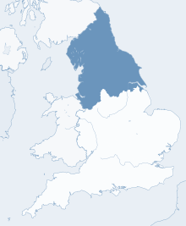

North of England
If you are an artist living and working in the north of England, you can apply.

The counties of the north of England are
- Cheshire
- Cumbria
- County Durham
- East Riding of Yorkshire
- Greater Manchester
- Lancashire
- Merseyside
- Northumberland
- North Yorkshire
- South Yorkshire
- Tyne and Wear
- West Yorkshire
- North Lincolnshire
- North East Lincolnshire.
What it is all about

For 4 individuals
The aim of the grant is to help 4 individuals or groups who want to develop their practice. We ask them to work around the ideas of belonging, and the ways in which we understand and construct who we are.

We call it RADICAL ANCESTRY.

What we offer

3 months

- Help and advice for 3 months to help you develop an idea that we will present online.

£

- £2500 to pay you a fee as an artist and £1500 to produce your artwork.

- We will share your work online and promote it publicly.

What we are looking for

We are working on the theme of RADICAL ANCESTRY.

We want you to tell us about your idea of a work about RADICAL ANCESTRY for online presentation.

Your work could explore a range of interwoven ideas from different perspectives, thinking about how we understand notions of “belonging”.
- Where do you think you belong, and where do you want to exist?
- How does technology allow us to explore new ways of thinking and experiment with who we are? How might we move towards more inclusive understandings of what it means to belong?

Your idea can take any format that can be presented as online work and on our LED window:
- Audio
- Video
- Text
- Games
- App design
- Virtual or augmented reality
- Performance
- Socially-engaged practice
- Web or desktop
- Animation
- Social media
- Workshops
You can apply even if you have never created digital or online work before.

Who it is for

North of England

You can apply if:

☐ You live or work in the North of England.

At least 2 years
of practice
☐ You started working on your practice more than 2 years ago.

☐ You have an idea for an artwork that responds to our themes.

You can apply even if you have never created digital or online work before.

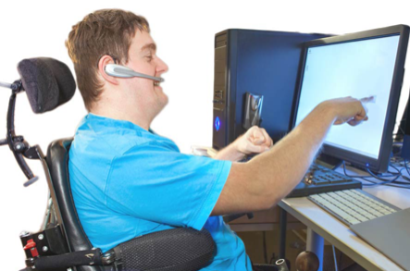
We want everyone to be able to participate.

If you have any access requirements, we can make changes to help you participate.

We call these changes reasonable adjustments.
How you will make it happen

You need to send us:

1. An explanation of your idea.

Your idea must
☐
- be about one of our themes on RADICAL ANCESTRY
☐
£ 1 300
- be possible to do with a fee of £2500 and production budget of £1500
☐
3 months
- be possible to do in 3 months

The final project should be ready to go online from November 2021.

2. A personal presentation

- You can send your proposal,and your CV or a description of your past work
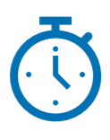
- You can send details of up to 5 past works.

Apply before
1 August 2021
midnight
Apply here <<link to webpage>>
The last day to apply is 1 August 2021.

How to present your application

1. An explanation of your idea.
750 words

- You can write a proposal with a maximum of 750 words.

- Or you can do an audio or a video of maximum 3 minutes.
OR

What we want to know about your idea

- What you will do
3 minutes
- How it is linked to themes around RADICAL ANCESTRY
- Why it is this the right opportunity for you
- What you want to get out of it
- What you will spend the money on
- The different parts of your project and when they will happen
- How your work can go online

2. A personal presentation

How to tell us about your past work

- You can send your artist statement, CV and the detail of up to 5 past works. It can be
  - Images
  - text files
  - social media links
  - recordings
  - or a link to your website.

How we will select the 4 artists

Our Programme Team will look at every application received.

For every candidate, we will check that

- They live and work in the north of England

- They started working on their practice more than 2 years ago
- They have an idea for an artwork that responds to our themes and is to be experienced online.

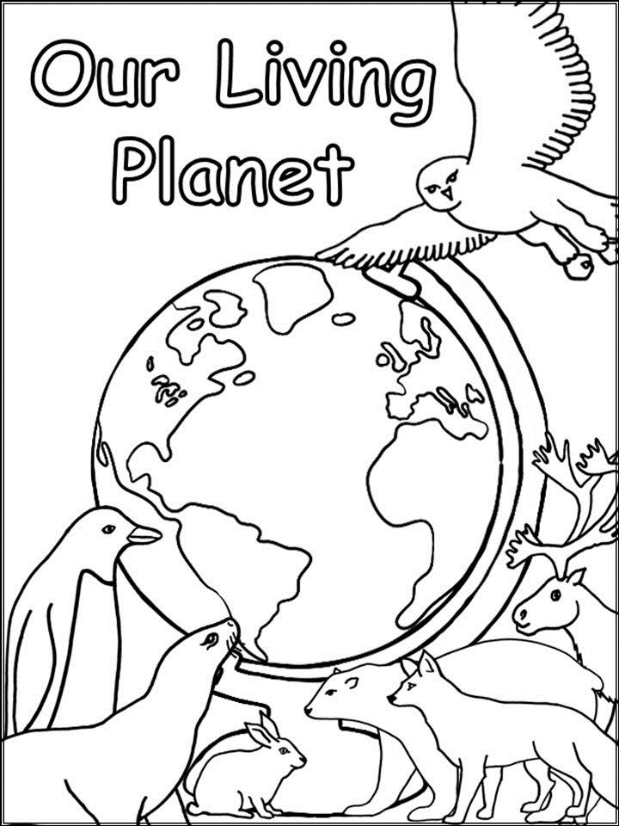
Then, we will choose the 4 ideas that

- fit the best with one of our themes on RADICAL ANCESTRY
£
- are possible to do with £ £2500 fee and £1500 production budget

- are possible to do in 3 months
3 months

Key dates

Sunday 1 August 2021 Last day to send your application

23 August 2021 We will give you our decision

in late August 2021 We will talk with the artists selected

The artists selected will need to send us an invoice. We will pay 30 days after we receive the invoice.

from November 2021 We will publish the artworks

The artists selected will need to send us an invoice. We will pay 30 days after we receive the invoice.

We can help you and talk with you more about this opportunity if you have any accessibility concerns or requirements.
Need help?
residency@fact.co.uk
0151 707 4444

To discuss with a member of our team,
please contact residency@fact.co.uk
or call 0151 707 4444

